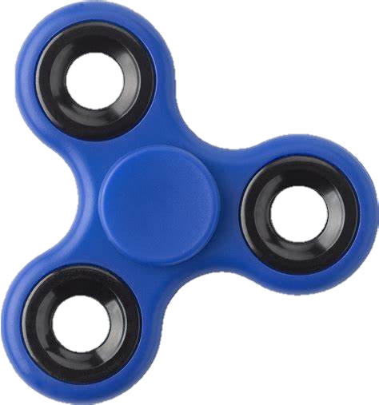

**COMSATs University Islamabad**

**Attock Campus**

Muhammad Kaleem Ullah

Fa19-bce-007

Computer-Aided Engineering Design

Engr. Shahab Yousafzai

Date: 26/06/2021

Fidget Spinner

**3D Model**

Table of Contents

abstract 2

INTRODUCTION 2

Methodology 3

Conclusion 6

# abstract

This document will provide you the overview about the 3D modal of the fidget spinner. The software we used for the model is AutoCAD. The objectives of the project are (1) to get familiar with the 3D interference of the AutoCAD, (2) to increase the productivity of the designer, (3) to improve the quality of design. Following are the 3 main things we follow to create our desire model of fidget spinner.

## See the source imageINTRODUCTION

A fidget spinner is a toy that consists of a ball bearing in the center of a multi-lobed (typically two or three) flat structure made from metal or plastic designed to spin along its axis with very little effort. A person holds the center pad while the toy spins. They are made from various materials including brass, stainless steel, titanium, copper, aluminum, and plastic. The rapid increase in the popularity of fidget spinners was in year 2017. Some teacher argued that the spinners distracted students from their schoolwork. According to a survey conducted by Alexi Roy and published in May 2017

32% of the largest 200 American public and private high schools had banned spinners on campus.

The basic diagram from which I have created is shown below

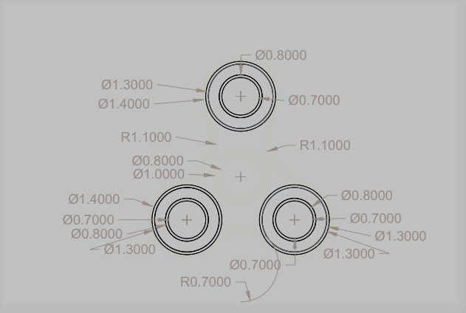

### Methodology

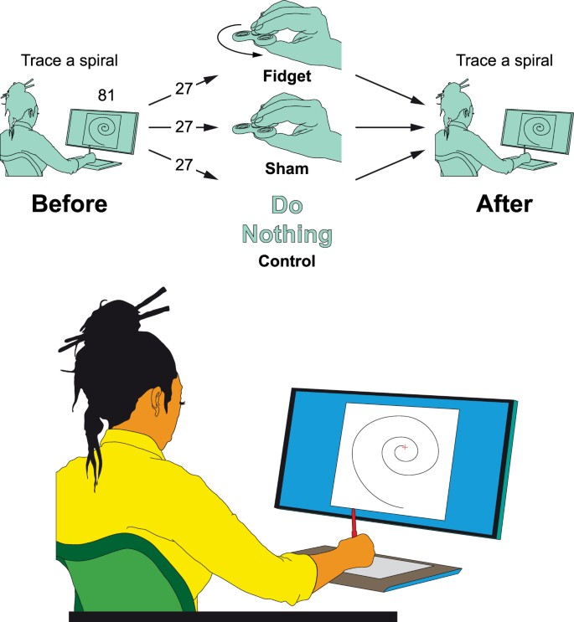

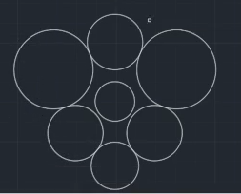The very first thing we did was change the AutoCAD view from 2D to 3D. As the three edges of the shape were clear so, I created circle on all the edges with equal distance and used the offset command to make small circles within the circle than I draw a TTR circle between three of the circles and created the circle in the center which is the place to hold spinner to rotate it.

Then I trimmed the unnecessary edges and the spinner shape was somehow clear at that time.

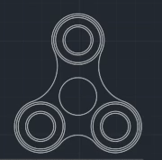

After that we used the press pulled command to make that same thing downward. We have made the middle circle little more downward and upward too to make that clearer as a center and distinguish that from other edges. After that we have used filled edges command to make those edges round.

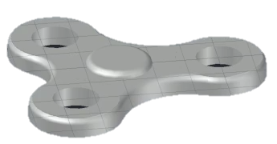

After that we have color and give dimensions to our design as shown in the below

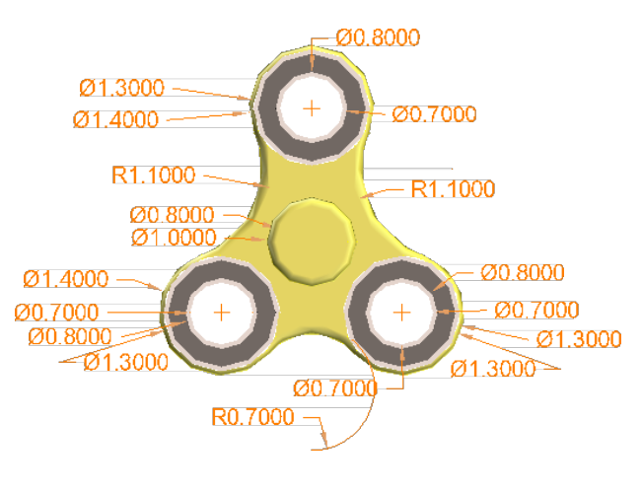

**Note:** The dimensions and colors were on the two different layer we can turn them on and off.

## Conclusion

After completing this project, we have learned how to:

* Present better visualization of the product.
* Use different commands in AutoCAD.
* 3D modeling, coloring, layers.
* Practice on AutoCAD’s different tool.

After following all the above commands, I have mentioned, finally we are able to get our final result.

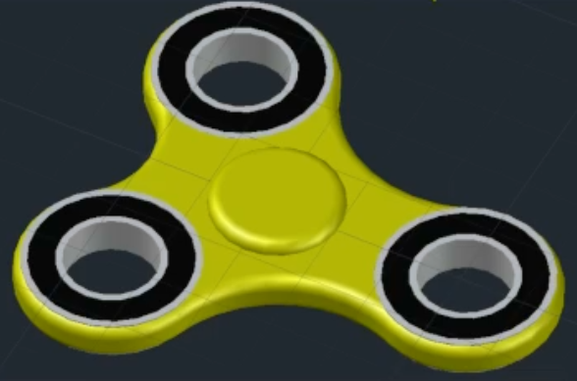

Following link is the main reference from which I get the idea, dimensions and sample of the fidget spinner.

* [**Reference 1**](https://www.youtube.com/watch?v=CioATs7NTLc)